1. **Grid Search**

from sklearn.model_selection import GridSearchCV

from sklearn.ensemble import RandomForestClassifier

# Define the model

model = RandomForestClassifier()

# Specify the hyperparameters to tune

param_grid = {

    'n_estimators': [10, 50, 100],

    'max_depth': [10, 20, None]

}

# Perform grid search

grid_search = GridSearchCV(estimator=model, param_grid=param_grid, cv=5)

grid_search.fit(X_train, y_train)

# Get the best parameters

print(grid_search.best_params_)

1. **PIPELINES**

**B4 PIPELINE**

from sklearn.preprocessing import StandardScaler

from sklearn.neighbors import KNeighborsClassifier

from sklearn.model_selection import train_test_split, GridSearchCV

from sklearn.ensemble import RandomForestClassifier

from sklearn.pipeline import Pipeline

# Split the predictor and target variables

y = df['quality']

X = df.drop(columns='quality')

# Split into training and test sets

X_train, X_test, y_train, y_test = train_test_split(X,y,test_size=0.25,random_state=42)

# Instantiate StandardScaler

scaler = StandardScaler()

# Transform the training and test sets

scaled_data_train = scaler.fit_transform(X_train)

scaled_data_test = scaler.transform(X_test)

# Convert into a DataFrame(Conver scaled data to datafrmae)

scaled_df_train = pd.DataFrame(scaled_data_train, columns=X_train.columns)

scaled_df_train.head()

# Instantiate KNeighborsClassifier

clf = KNeighborsClassifier()

# Fit the classifier

clf.fit(scaled_data_train,y_train)

# Print the accuracy on test set

clf.score(scaled_data_test,y_test)

**AFTER PIPELINE**

# Split into training and test sets

X_train, X_test, y_train, y_test = train_test_split(X,y,test_size=0.25,random_state=42)

# Build a pipeline with StandardScaler and KNeighborsClassifier

scaled_pipeline_1 = Pipeline([('mms',StandardScaler()),

                              ('knn',KNeighborsClassifier())

                              ])

# Fit the training data to pipeline

scaled_pipeline_1.fit(scaled_data_train,y_train)

# Print the accuracy on test set

scaled_pipeline_1.score(scaled_data_test,y_test)

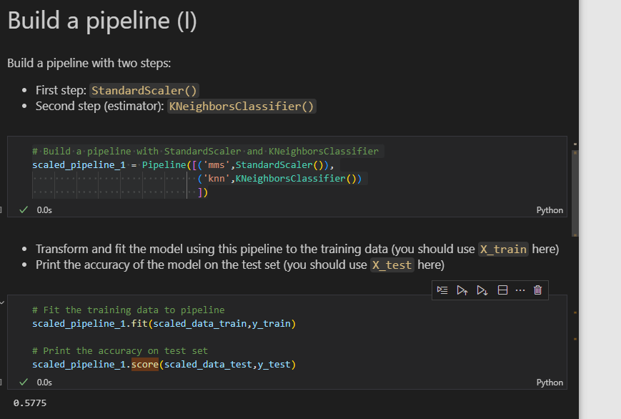

**PIPELINE 2**

# Create a pipeline

pipeline = Pipeline([

    ('scaler', StandardScaler()),  # Step 1: Standardize the features

    ('classifier', RandomForestClassifier())  # Step 2: Train a Random Forest model

])

# Train the pipeline

pipeline.fit(X_train, y_train)

# Make predictions

y_pred = pipeline.predict(X_test)

# Evaluate the model

accuracy = (y_pred == y_test).mean()

print(f'Accuracy: {accuracy}')

1. **PIPELINE 3 –Best to use processing and modelling pipelines differently**

#Now define those steps for our pipeline

processor = Pipeline(steps=[

    ('imputer',SimpleImputer(strategy='median')),

    ('scaler',StandardScaler())

])

#we go ahead and test this on our X_train from before, to make sure we get the same result

processor.fit_transform(X_train).shape

# Now add the model - using another pipeline

pipe = Pipeline(steps=[

    ('preprocessor',processor),

    ('linreg',LinearRegression())

])

pipe.fit(X_train,y_train)

#Grab predictions out on our train and test sets, to evaluate

train_preds = pipe.predict(X_train)

test_preds =pipe.predict(X_test)

#print out R2-Score and Root Mean squared Error for our train and test data

print(f'Train set r2-score:{r2_score(y_train,train_preds)}')

print(f'Train set RMSE: {mean_squared_error(y_train,train_preds,squared=False)}')

print('*'*20)

print(f'test set r2-score:{r2_score(y_test,test_preds)}')

print(f'test set RMSE: {mean_squared_error(y_test,test_preds,squared=False)}')

#Import our cross validation

#Note that cross_val_score and cross_val_predict are variants of this function

from sklearn.model_selection import cross_validate

#Time to cross val!

#Pass in our pipeline and training dta ,set cv=5 and return the train score

#because we're using cross-validatte instead of cross_val_score , can set scoring  metrics

results = cross_validate(pipe,X_train,y_train,cv=5,

                         return_train_score=True,

                         scoring=['r2','neg_root_mean_squared_error']

                         )

results

#Let's look at the avreage, plus a meaure of variance for train and test

print(f'Average Train Set r2-Score: {results["train_r2"].mean()} +/- {results["train_r2"].std()}')

print(f'Average Train Set RMSE: {results["train_neg_root_mean_squared_error"].mean()*-1} +/- {results["train_neg_root_mean_squared_error"].std()}')

print('*'*20)

#Let's look at the avreage, plus a meaure of variance for train and test

print(f'Average test Set r2-Score: {results["test_r2"].mean()} +/- {results["test_r2"].std()}')

print(f'Average test Set RMSE: {results["test_neg_root_mean_squared_error"].mean()*-1} +/- {results["test_neg_root_mean_squared_error"].std()}')

1. **GRID SEARCH WITH PIPELINE**

# Build a pipeline with StandardScaler and RandomForestClassifier

scaled_pipeline_2 = Pipeline([

    ('ss',StandardScaler()),

    ('RF',RandomForestClassifier())

])

# Define the grid

grid = [{'RF__max_depth': [4, 5, 6],

         'RF__min_samples_split': [2, 5, 10],

         'RF__min_samples_leaf': [1, 3, 5]}]

# Define a grid search

gridsearch = GridSearchCV(estimator=scaled_pipeline_2,

                          param_grid=grid,

                          scoring='accuracy',

                          cv=5

                          )

# Fit the training data

gridsearch.fit(X_train,y_train)

# Print the accuracy on test set

gridsearch.score(X_test,y_test)

**GRID SEARCH WITH PIPELINE 2**

from sklearn.model_selection import GridSearchCV

# Define parameter grid

param_grid = {

    'classifier__n_estimators': [50, 100],  # 'classifier' is the RandomForest model

    'classifier__max_depth': [10, 20]

}

# Perform grid search on the pipeline

grid_search = GridSearchCV(pipeline, param_grid, cv=5)

grid_search.fit(X_train, y_train)

# Get best parameters

print("Best parameters:", grid_search.best_params_)

1. **GRID SEARCH CV SCORES 1**

# Mean training score

dt_gs_training_score = dt_grid_search.cv_results_['mean_train_score'].mean()

dt_gs_training_score

# # Mean test score

dt_gs_testing_score =  dt_grid_search.score(X_test,y_test)

print(f"Mean Training Score: {dt_gs_training_score :.2%}")

print(f"Mean Test Score: {dt_gs_testing_score :.2%}")

print("Best Parameter Combination Found During Grid Search:")

dt_grid_search.best_params_

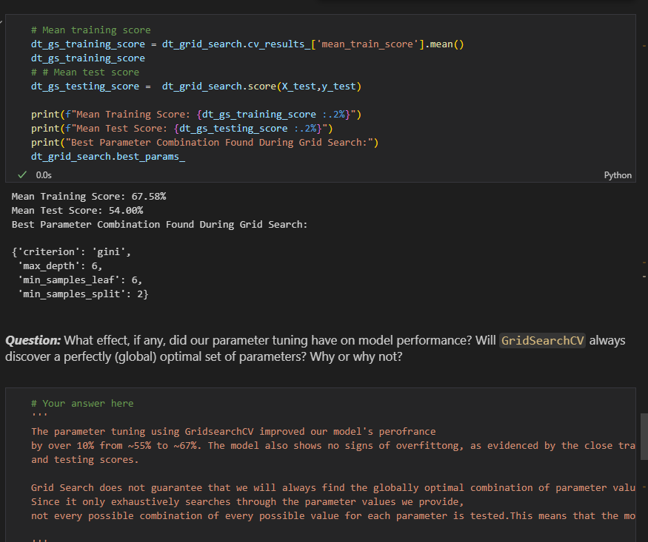

1. **GRID SEARCH CV SCORES 2**

rf_grid_search = GridSearchCV(rf_clf,rf_param_grid,cv=3)

rf_grid_search.fit(X_train,y_train)

print(f"Testing Accuracy: {rf_grid_search.best_score_ :.2%}")

print("")

print(f"Optimal Parameters: {rf_grid_search.best_params_}")

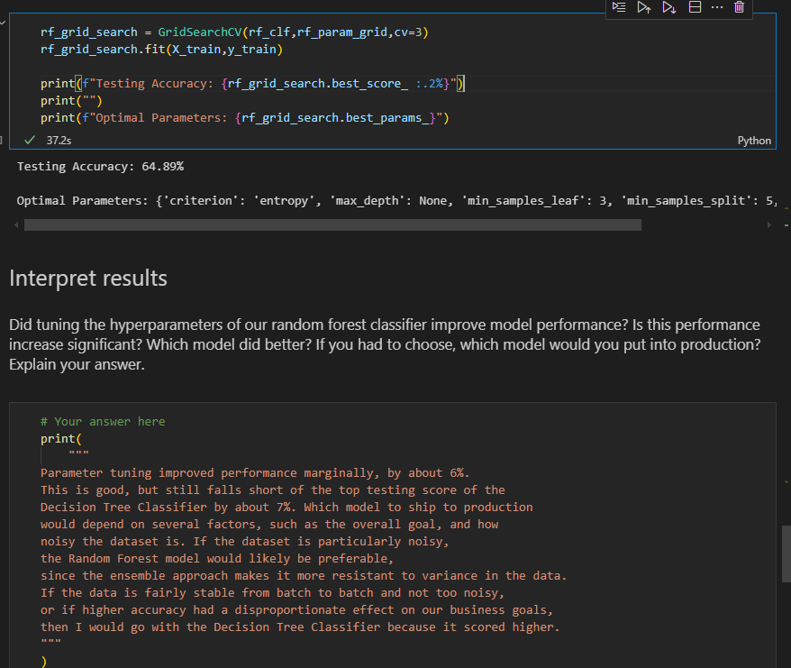

1. **Modify a pipeline(changing scaler and modelling)**

# Make Pipelines for stardadization and modeling

pipe = Pipeline([

    ('std',StandardScaler()),

    ('model',LogisticRegression())

])

# switching to Decision tree

from sklearn.tree import DecisionTreeClassifier

pipe.set_params(model=DecisionTreeClassifier())

pipe.set_params(std=MinMaxScaler())

1. **Example 2**

# Pipeline

pipe3 = Pipeline([

    ('pre-pro',transformer3),

    ('model',LogisticRegression())

])

Changing from logistic regression to Random forest

from sklearn.ensemble import RandomForestClassifier

pipe3.set_params(model=RandomForestClassifier())

pipe3.fit(X_train,y_train)

y_pred = pipe3.predict(X_test)

print(classification_report(y_true=y_test,y_pred=y_pred))

1. **Function transformer-** Let's say for the sake of example that we wanted to add a new feature called `number_odd`, which is `1` when the value of `number` is odd and `0` when the value of `number` is even.

from sklearn.preprocessing import FunctionTransformer

def is_odd(data):

    """

    Helper function that returns 1 if odd, 0 if even

    """

    return data % 2

# Instantiate transformer

func_transformer = FunctionTransformer(is_odd)

# Create transformed column

number_odd = func_transformer.fit_transform(example_X["number"])

# Add engineered column

example_X["number_odd"] = number_odd

example_X

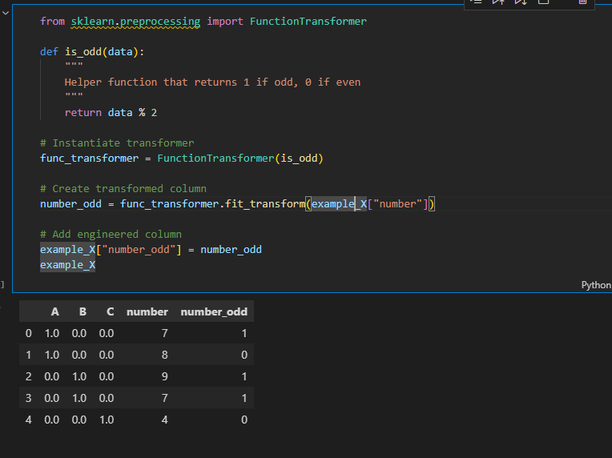

1. **Scaling**

from sklearn.preprocessing import StandardScaler

# Instantiate transformer

scaler = StandardScaler()

# Create transformed dataset

data_scaled = scaler.fit_transform(example_X)

# Replace dataset with transformed one

example_X = pd.DataFrame(

    data_scaled,

    columns=example_X.columns,

    index=example_X.index

)

example_X

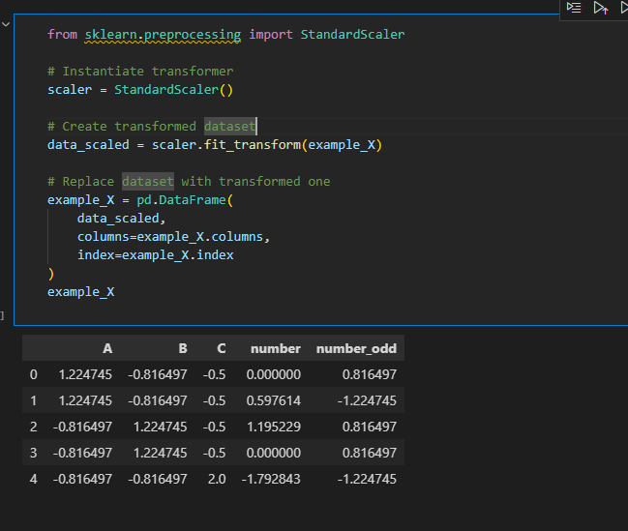

1. **Preprocessing without pipeline(**combine ohe and function transform above)

def preprocess_data_without_pipeline(X):

    transformers = []

    ### Encoding categorical data ###

    # Make a transformer

    ohe = OneHotEncoder(categories="auto", handle_unknown="ignore", sparse=False)

    # Create transformed dataframe

    category_encoded = ohe.fit_transform(X[["category"]])

    category_encoded = pd.DataFrame(

        category_encoded,

        columns=ohe.categories_[0],

        index=X.index

    )

    transformers.append(ohe)

    # Replace categorical data with encoded data

    X.drop("category", axis=1, inplace=True)

    X = pd.concat([category_encoded, X], axis=1)

    ### Feature engineering ###

    def is_odd(data):

        """

        Helper function that returns 1 if odd, 0 if even

        """

        return data % 2

    # Instantiate transformer

    func_transformer = FunctionTransformer(is_odd)

    # Create transformed column

    number_odd = func_transformer.fit_transform(X["number"])

    transformers.append(func_transformer)

    # Add engineered column

    X["number_odd"] = number_odd

    ### Scaling ###

    # Instantiate transformer

    scaler = StandardScaler()

    # Create transformed dataset

    data_scaled = scaler.fit_transform(X)

    transformers.append(scaler)

    # Replace dataset with transformed one

    X = pd.DataFrame(

        data_scaled,

        columns=X.columns,

        index=X.index

    )

    return X, transformers

# Reset value of example_X

example_X = example_data.drop("target", axis=1)

# Test out our function

result, transformers = preprocess_data_without_pipeline(example_X)

result

1. **Column Transformer 1**

from sklearn.compose import ColumnTransformer

from sklearn.pipeline import Pipeline

# Reset value of example_X

example_X = example_data.drop("target", axis=1)

# Create a column transformer

col_transformer = ColumnTransformer(transformers=[

    ("ohe", OneHotEncoder(categories="auto", handle_unknown="ignore"),

["category"])

], remainder="passthrough")

# Create a pipeline containing the single column transformer

pipe = Pipeline(steps=[

    ("col_transformer", col_transformer)

])

# Use the pipeline to fit and transform the data

transformed_data = pipe.fit_transform(example_X)

transformed_data

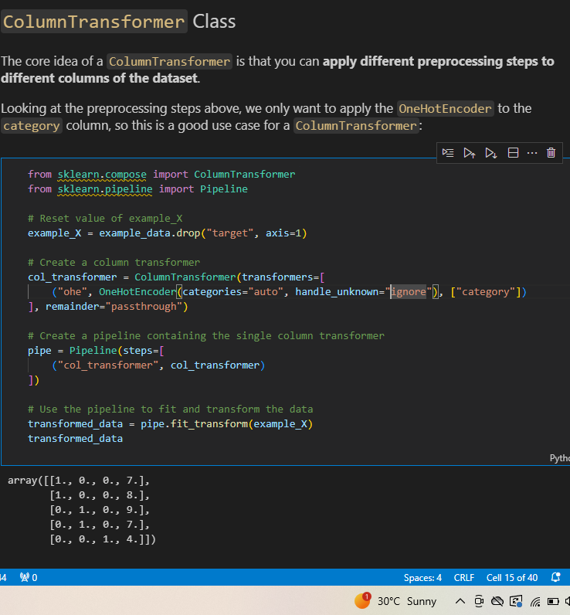

import numpy as np

# Extract the category labels from the OHE within the pipeline

encoder = col_transformer.named_transformers_["ohe"]

category_labels = encoder.categories_[0]

# Make a dataframe with the relevant columns

pd.DataFrame(transformed_data, columns=np.append(category_labels, "number"))

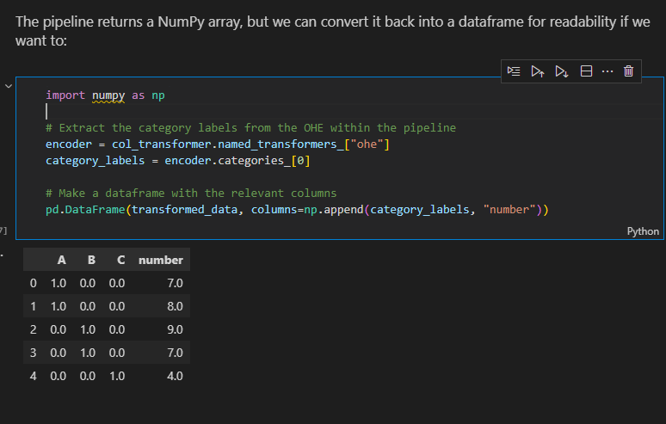

**Column Transfomer 2(becomes messy for many processing)**

#Creating tranformer

transfomer = ColumnTransformer([

    ('ohe',OneHotEncoder(),['Sex']),

    ('impute',SimpleImputer(strategy='mean'),['Age','Fare']),

    ('std',MinMaxScaler(),['Age','Fare'])

])

# Pipeline

pipe = Pipeline([

    ('pre-pro',transfomer),

    ('model',LogisticRegression())

])

# re assign X and y

X=orginal_df.drop("Survived",axis=1)

y=orginal_df["Survived"]

# train_test_split

X_train,X_test,y_train,y_test = train_test_split(X,y,test_size=20,random_state=42)

# fit and make predictions

pipe.fit(X_train,y_train)

y_pred = pipe.predict(X_test)

y_pred

print(classification_report(y_true=y_test,y_pred=y_pred))

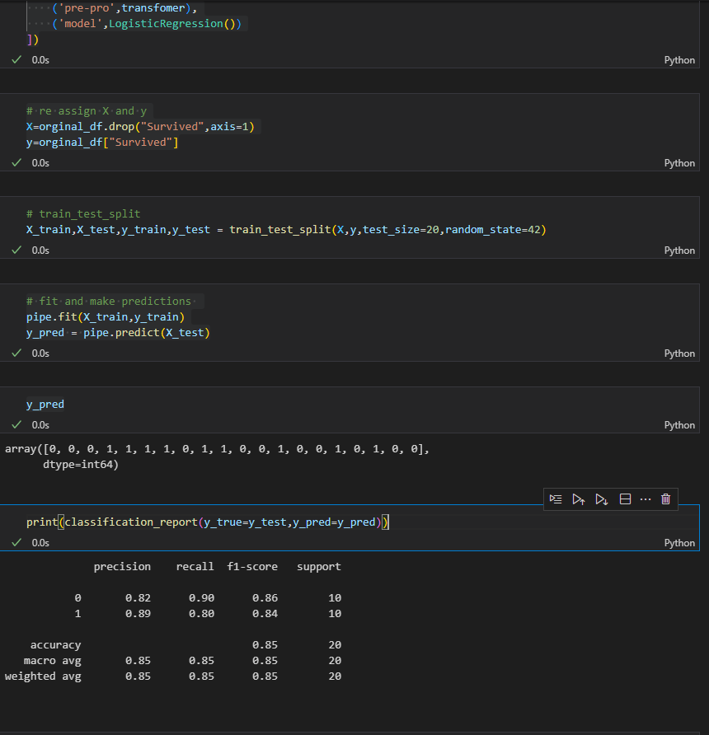

1. **Column Transfomer 3(best)**

from sklearn.compose import ColumnTransformer

# cat_ord=['grades']

transformer3 = ColumnTransformer([

    ('ohe_sex',Pipeline([

        ('impute_mode',SimpleImputer(strategy='most_frequent')),

        ('ohe',OneHotEncoder())

    ]),['Sex']),

    ('pre_age',Pipeline([

        ('impute_mean',SimpleImputer(strategy='mean')),

        ('scaler',MinMaxScaler())

    ]),['Age'])

    # ('ordinal',Pipeline([

    # ]),cat_ord)

])

# Pipeline

pipe3 = Pipeline([

    ('pre-pro',transformer3),

    ('model',LogisticRegression())

])

# re assign X and y

X=orginal_df.drop("Survived",axis=1)

y=orginal_df["Survived"]

# train_test_split

X_train,X_test,y_train,y_test = train_test_split(X,y,test_size=20,random_state=42)

# fit and make predictions

pipe3.fit(X_train,y_train)

y_pred = pipe3.predict(X_test)

print(classification_report(y_true=y_test,y_pred=y_pred))

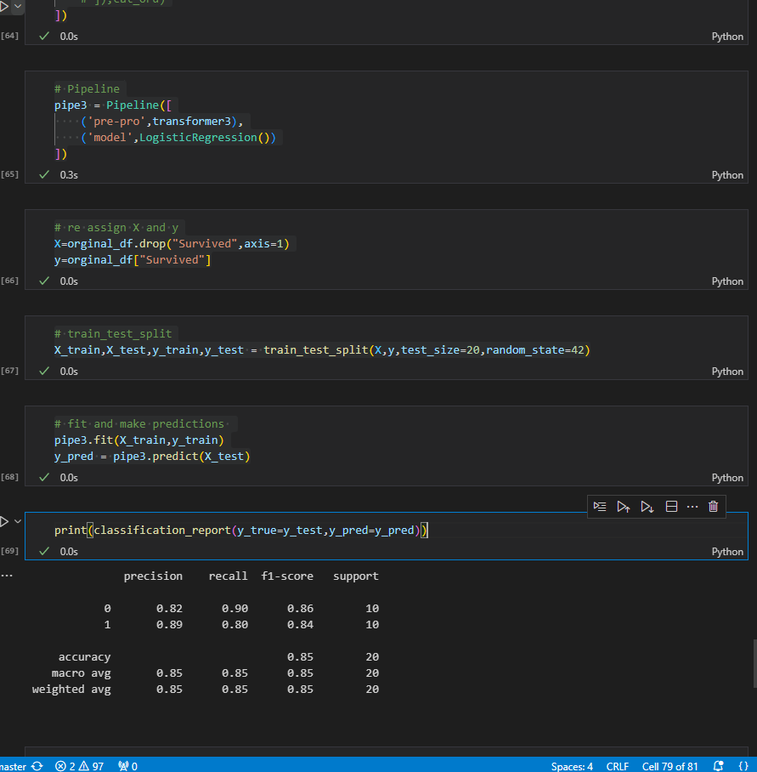

**SET PARAMS(SET_PARAMS)- Change from Logistic Regression to Random Forest**

from sklearn.ensemble import RandomForestClassifier

pipe3.set_params(model=RandomForestClassifier())

pipe3.fit(X_train,y_train)

y_pred = pipe3.predict(X_test)

print(classification_report(y_true=y_test,y_pred=y_pred))

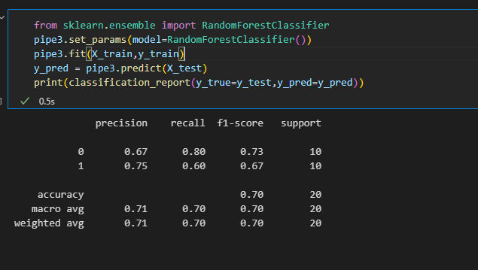

1. **Feature Union**

# Create a ColumnTransformer for feature engineering

feature_eng = ColumnTransformer(transformers=[

    ("add_number_odd", FunctionTransformer(is_odd), ["number"])

], remainder="drop")

# Create a ColumnTransformer to encode categorical data

# and keep numeric data as-is

original_features_encoded = ColumnTransformer(transformers=[

    ("ohe", OneHotEncoder(categories="auto", handle_unknown="ignore"), ["category"])

], remainder="passthrough")

from sklearn.pipeline import FeatureUnion

feature_union = FeatureUnion(transformer_list=[

    ("encoded_features", original_features_encoded),

    ("engineered_features", feature_eng)

])

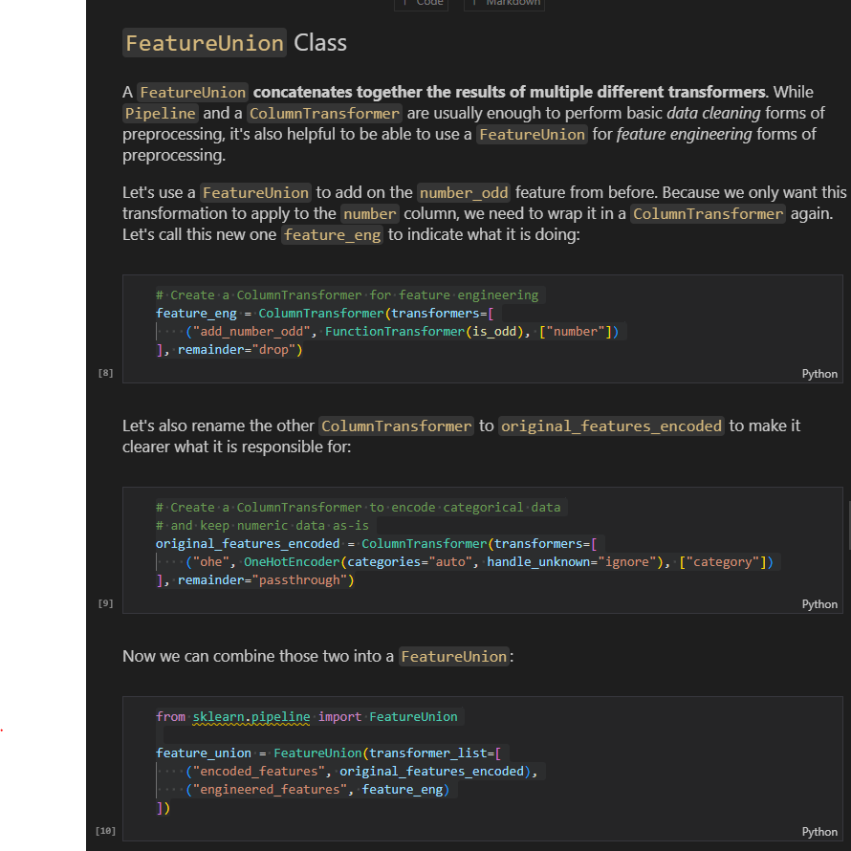

**.**

# Create a pipeline containing union of encoded

# original features and engineered features

pipe = Pipeline(steps=[

    ("feature_union", feature_union)

])

# Use the pipeline to fit and transform the data

transformed_data = pipe.fit_transform(example_X)

transformed_data

# Extract the category labels from the OHE within the pipeline

encoder = original_features_encoded.named_transformers_["ohe"]

category_labels = encoder.categories_[0]

# Make a dataframe with the relevant columns

all_cols = list(category_labels) + ["number", "number_odd"]

pd.DataFrame(transformed_data, columns=all_cols)

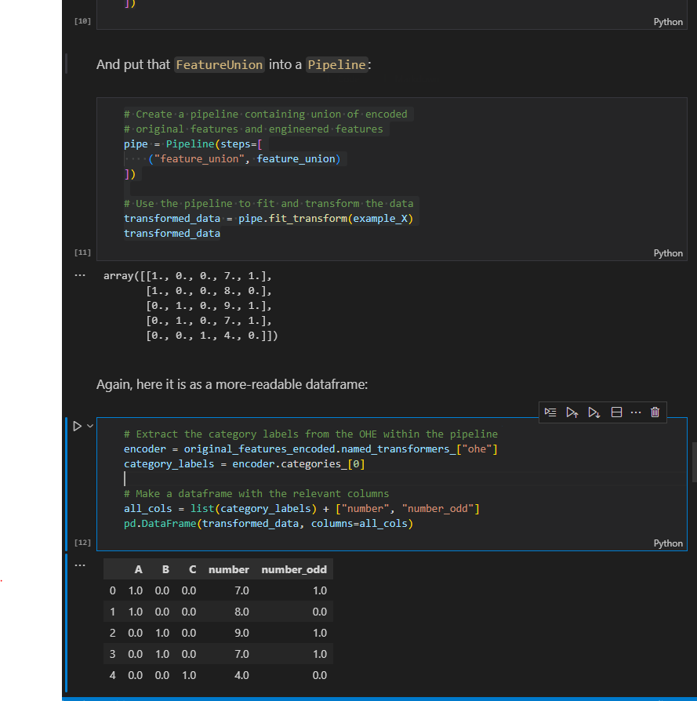

**If we want to add an estimator (model) as the last step we can do like this**

from sklearn.linear_model import LogisticRegression

# Create a pipeline containing union of encoded

# original features and engineered features, then

# all features scaled, then feed into a model

pipe = Pipeline(steps=[

    ("feature_union", feature_union),

    ("scale", StandardScaler()),

    ("model", LogisticRegression())

])

# Use the pipeline to fit the model and score it

pipe.fit(example_X, example_y)

pipe.score(example_X, example_y)

**COMPLETE REFACTORED PIPELINE EXAMPLE**

def preprocess_data_with_pipeline(X):

    ### Encoding categorical data ###

    original_features_encoded = ColumnTransformer(transformers=[

        ("ohe", OneHotEncoder(categories="auto", handle_unknown="ignore"), ["category"])

    ], remainder="passthrough")

    ### Feature engineering ###

    def is_odd(data):

        """

        Helper function that returns 1 if odd, 0 if even

        """

        return data % 2

    feature_eng = ColumnTransformer(transformers=[

        ("add_number_odd", FunctionTransformer(is_odd), ["number"])

    ], remainder="drop")

    ### Combine encoded and engineered features ###

    feature_union = FeatureUnion(transformer_list=[

        ("encoded_features", original_features_encoded),

        ("engineered_features", feature_eng)

    ])

    ### Pipeline (including scaling) ###

    pipe = Pipeline(steps=[

        ("feature_union", feature_union),

        ("scale", StandardScaler())

    ])

    transformed_data = pipe.fit_transform(X)

    ### Re-apply labels (optional step for readability) ###

    encoder = original_features_encoded.named_transformers_["ohe"]

    category_labels = encoder.categories_[0]

    all_cols = list(category_labels) + ["number", "number_odd"]

    return pd.DataFrame(transformed_data, columns=all_cols, index=X.index), pipe

# Reset value of example_X

example_X = example_data.drop("target", axis=1)

# Test out our new function

result, pipe = preprocess_data_with_pipeline(example_X)

result

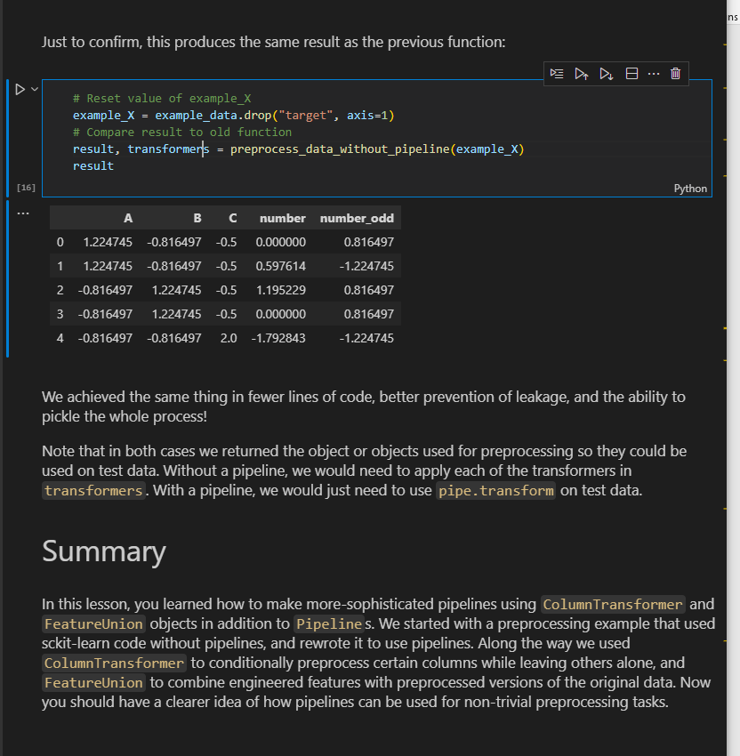

1. **Using simple imputer and scaling**

# Instantiate our imputer

imputer =  SimpleImputer(strategy='median')

#Fit our imputer on the training data

imputer.fit(X_train)

#create no-null versions of our train and test data

X_train_no_nulls = imputer.transform(X_train)

X_test_no_nulls = imputer.transform(X_test)

#instantiate our scaler

scaler = StandardScaler()

#Fit our scaler on the no-null training data

scaler.fit(X_train_no_nulls)

#create processed versions of our train and test data

X_train_processed= scaler.transform(X_train_no_nulls)

X_test_processed = scaler.transform(X_test_no_nulls)

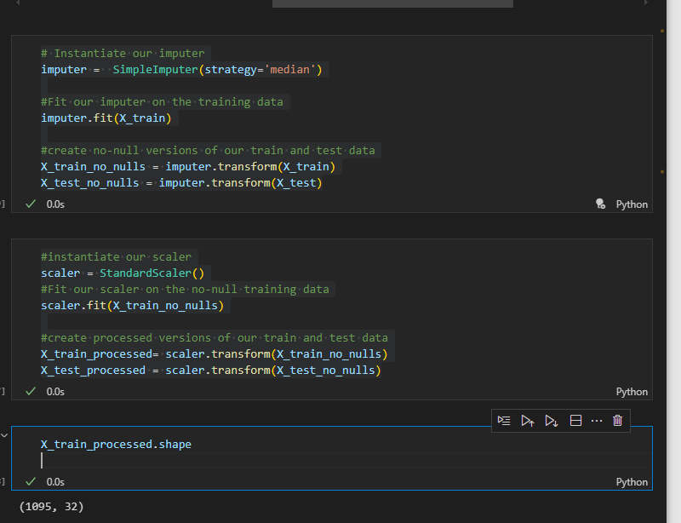

1. **Bagging**

# Instantiate a BaggingClassifier

bagged_tree = BaggingClassifier(DecisionTreeClassifier(criterion='gini',max_depth=5),n_estimators=20)

# Fit to the training data

bagged_tree.fit(data_train,target_train)

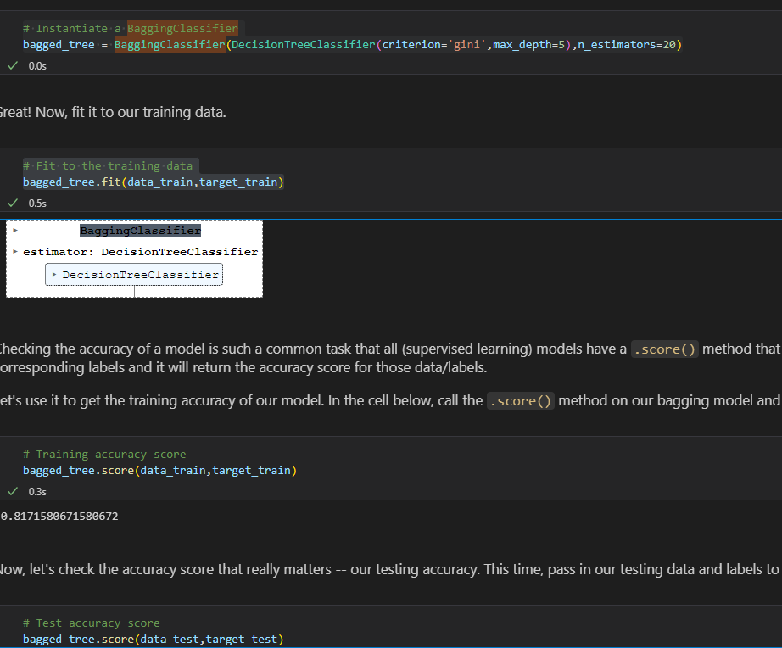

1. **Random Forest**

forest = RandomForestClassifier(n_estimators=100,max_depth=5)

forest.fit(data_train,target_train)

# Training accuracy score

forest.score(data_train,target_train)

# Test accuracy score

forest.score(data_test,target_test)

plot_feature_importances(forest)

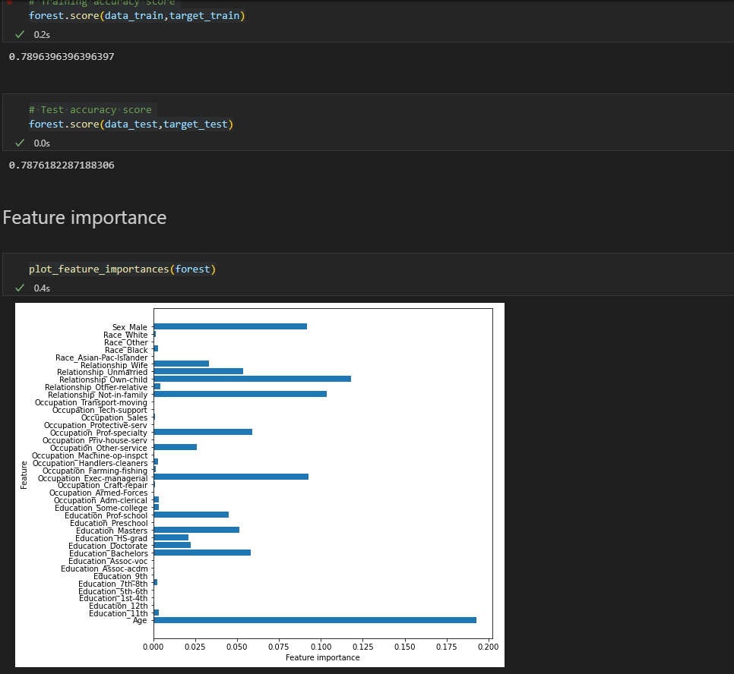

**Trees in the forest**

# First tree from forest_2

rf_tree_1 = forest_2.estimators_[0]

rf_tree_1

# Feature importance

plot_feature_importances(rf_tree_1)

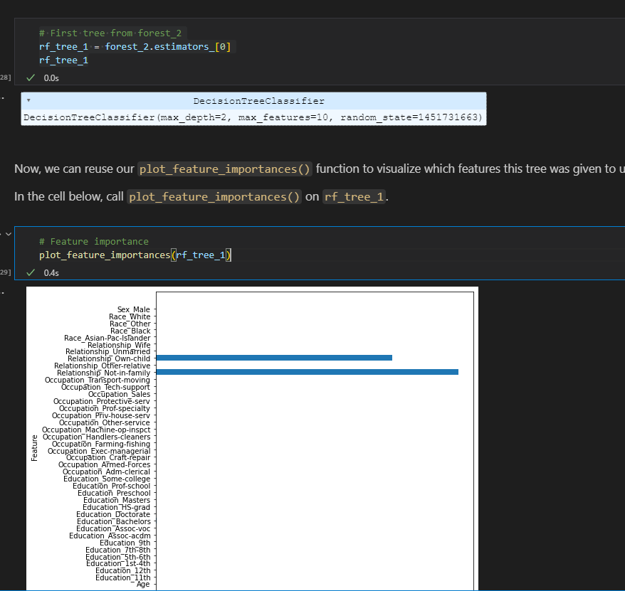

**Second Tree**

# Second tree from forest_2

rf_tree_2 = forest_2.estimators_[1]

rf_tree_2

# Feature importance

plot_feature_importances(rf_tree_2)

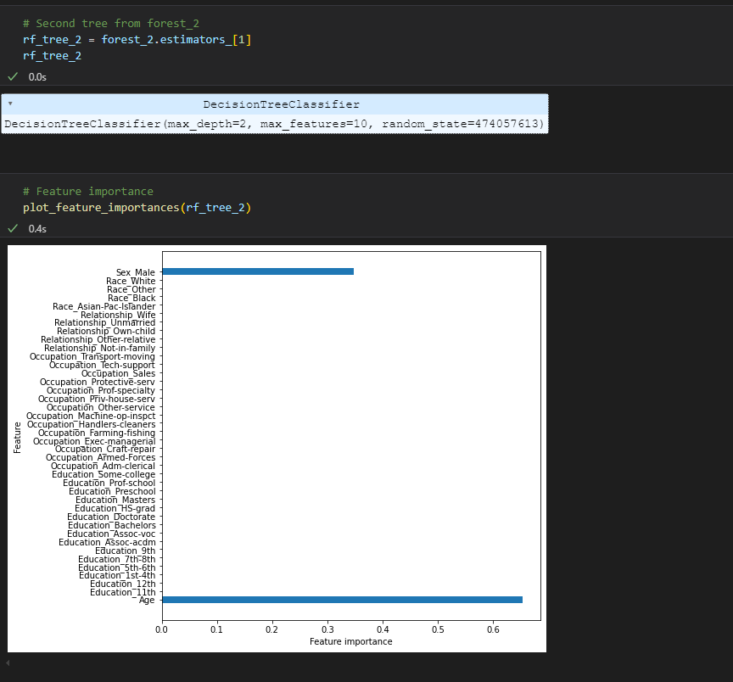

1. **XG BOOST**

Requires that classification categories be integers that count up from 0, not starting at 3. Therefore you should instantiate a `LabelEncoder`and convert both `y_train` and `y_test` into arrays containing label encoded values (i.e. integers that count up from 0).

# Instantiate the encoder

encoder = LabelEncoder()

# Fit and transform the training data

y_train = pd.Series(encoder.fit_transform(y_train))

# # Transform the test data

y_test = pd.Series(encoder.fit_transform(y_test))

# Your code here to inspect the values of y_train and y_test

y_train.value_counts().sort_index()

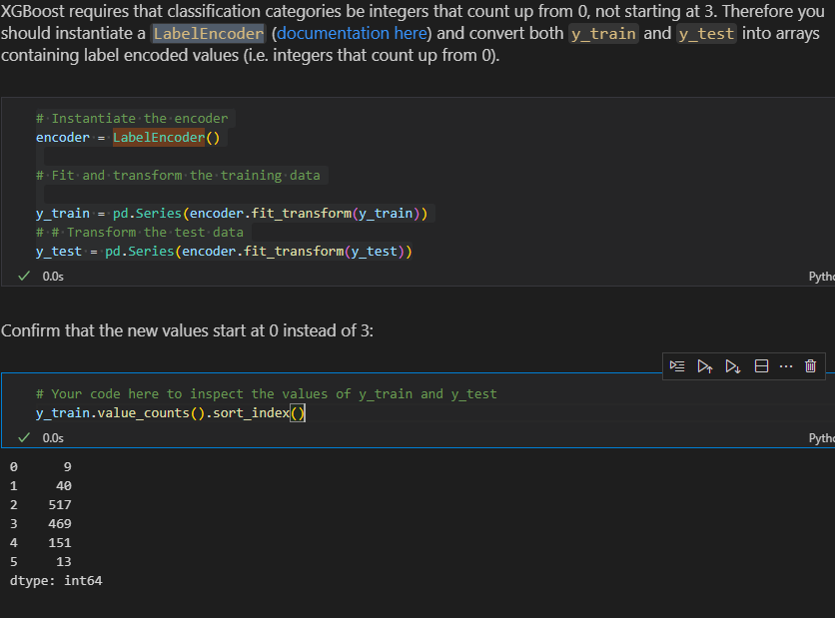

**Build XGBOOST Model**

from xgboost import XGBClassifier

# Instantiate XGBClassifier

clf = XGBClassifier()

# Fit XGBClassifier

clf.fit(X_train,y_train)

# Predict on training and test sets

training_preds = clf.predict(X_train)

test_preds = clf.predict(X_test)

# Accuracy of training and test sets

training_accuracy = accuracy_score(y_train,training_preds)

test_accuracy = accuracy_score(y_test,test_preds)

print('Training Accuracy: {:.4}%'.format(training_accuracy * 100))

print('Validation accuracy: {:.4}%'.format(test_accuracy * 100))

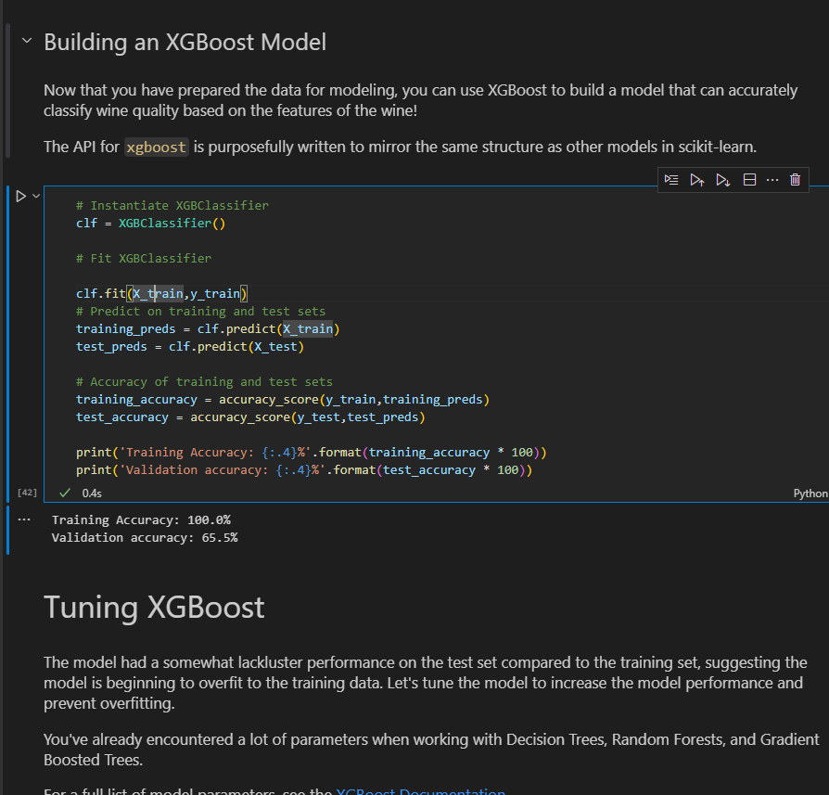

**TUNING XGBOOST**

param_grid = {

    'learning_rate': [0.1, 0.2],

    'max_depth': [6],

    'min_child_weight': [1, 2],

    'subsample': [0.5, 0.7],

    'n_estimators': [100],

}

grid_clf = GridSearchCV(clf,param_grid,cv=None,n_jobs=1)

grid_clf.fit(X_train, y_train)

best_parameters = grid_clf.best_params_

print('Grid Search found the following optimal parameters: ')

for param_name in sorted(best_parameters.keys()):

    print('%s: %r' % (param_name, best_parameters[param_name]))

training_preds = grid_clf.predict(X_train)

test_preds = grid_clf.predict(X_test)

training_accuracy = accuracy_score(y_train,training_preds)

test_accuracy = accuracy_score(y_test,test_preds)

print('')

print('Training Accuracy: {:.4}%'.format(training_accuracy * 100))

print('Validation accuracy: {:.4}%'.format(test_accuracy * 100))

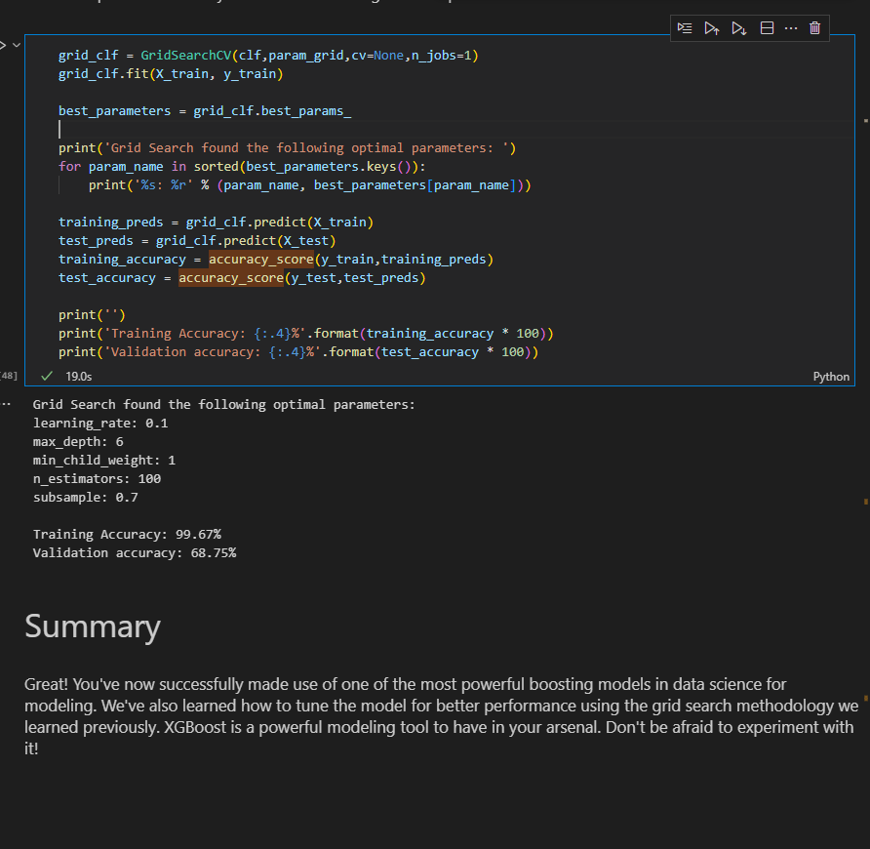

1. **PROJECT ON PIPELINES AND ENSEMBLE METHODS**

X = df.drop("Target",axis=1)

y = df["Target"]

X_train,X_test,y_train,y_test = train_test_split(X,y,train_size=0.2,random_state=42)

cat_cols = ["Education","Occupation","Relationship","Race","Sex"]

num_cols = ["Age"]

#create a tranformer

transfomer = ColumnTransformer([

    ('cat',Pipeline([

        ('imputer',SimpleImputer(strategy='most_frequent')),

        ('ohe',OneHotEncoder())

    ]),cat_cols),

    ('num',Pipeline([

        ('imputer',SimpleImputer(strategy='mean')),

        ('scaler',MinMaxScaler())

    ]),num_cols)

])

# base estimator for ensemble methods

base= DecisionTreeClassifier(class_weight='balanced')

# create a pipeline

pipe = Pipeline([

    ('pre_pro',transfomer),

    ('model',DecisionTreeClassifier(class_weight='balanced'))

])

# fit and predict

pipe.fit(X_train,y_train)

y_pred = pipe.predict(X_test)

# print report

print(classification_report(y_test,y_pred))

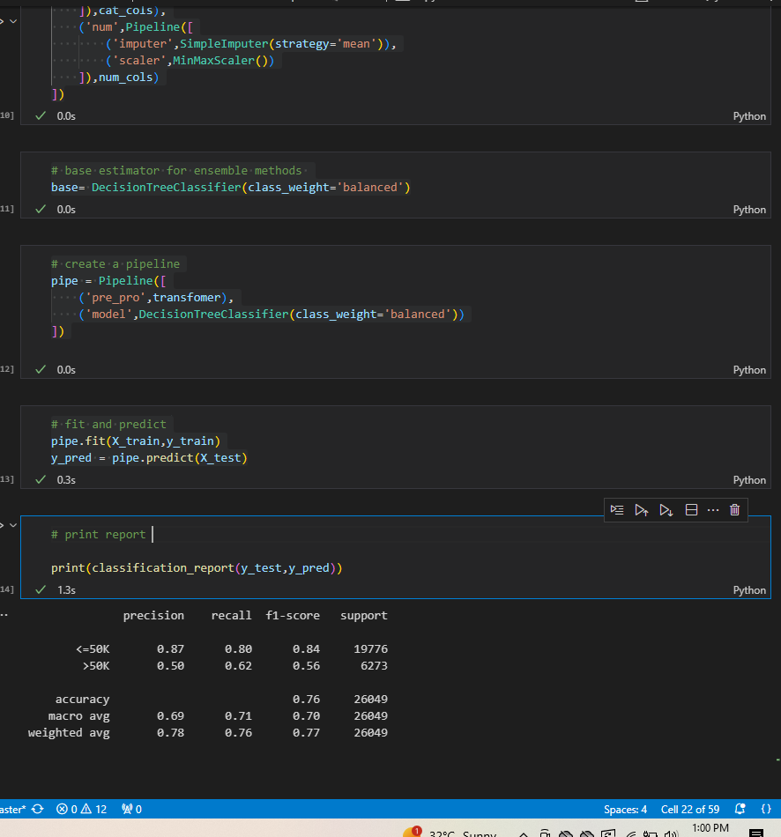

**Change to Bagging model(Using set params)**

# set up a BaggingClassifier

pipe.set_params(model=BaggingClassifier(base_estimator=base))

# fit and predict

pipe.fit(X_train,y_train)

y_pred = pipe.predict(X_test)

# print report

print(classification_report(y_test,y_pred))

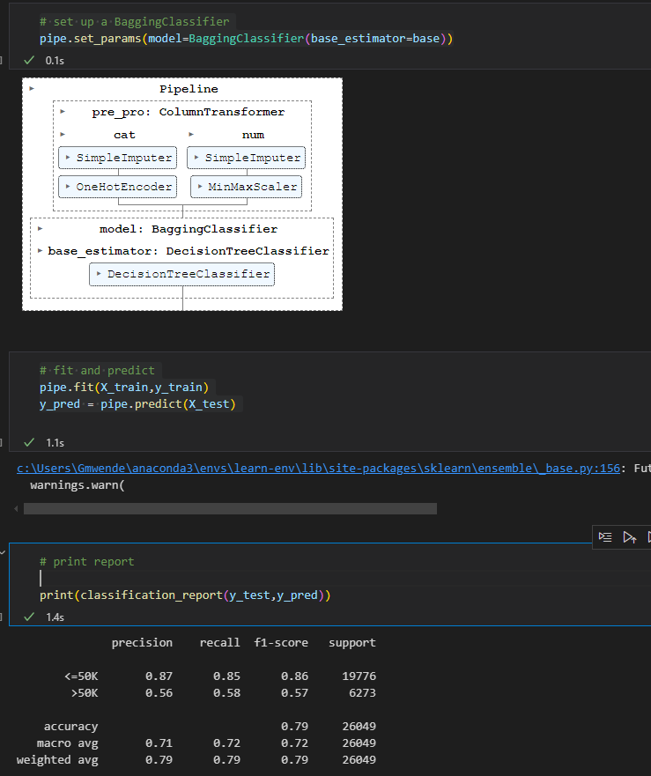

**CHANGE TO RANDOM FOREST**

# set up Random Forest Classifier

pipe.set_params(model=RandomForestClassifier(class_weight='balanced',n_estimators=300))

# fit and predict

pipe.fit(X_train,y_train)

y_pred = pipe.predict(X_test)

print(classification_report(y_test,y_pred))

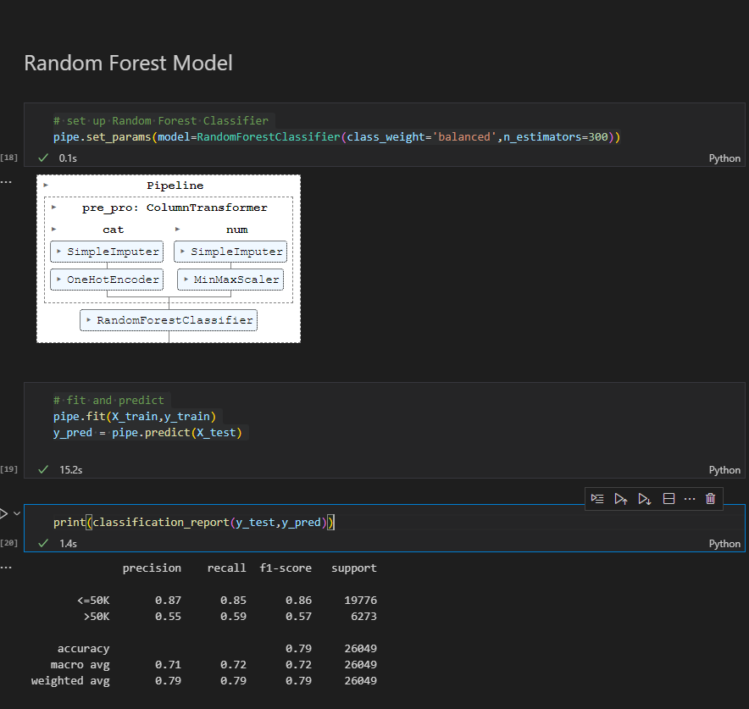

**CHANGE TO ADABOOST**

# set up adaboost classifier

# pipe.set_params(model=AdaBoostClassifier(n_estimators=base))

pipe.set_params(model=AdaBoostClassifier(base_estimator=base))

# fit and predict

pipe.fit(X_train,y_train)

y_pred = pipe.predict(X_test)

print(classification_report(y_test,y_pred))

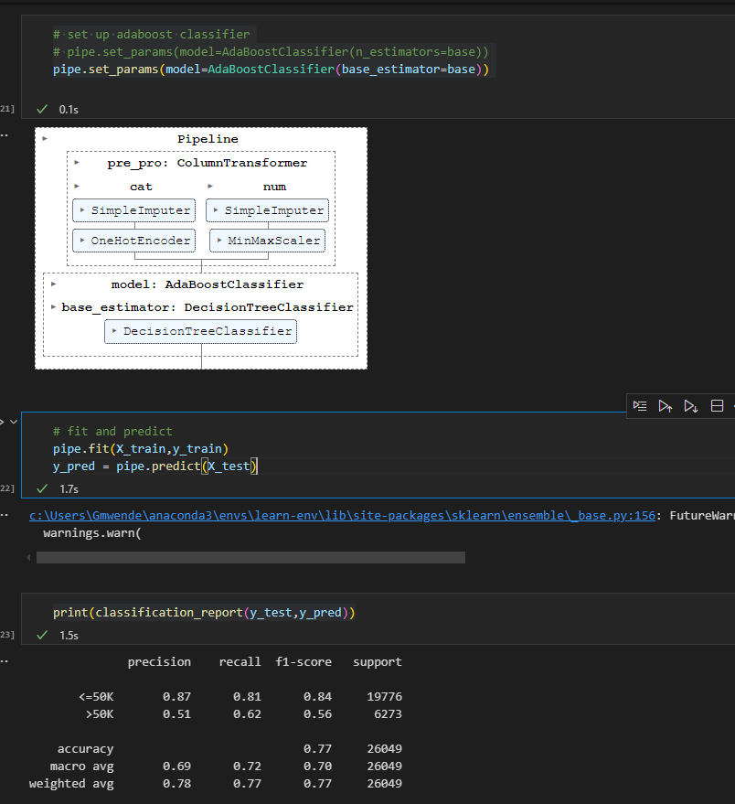

**Change to Gradient Boosting**

# Gradient Bossting model

# set up adaboost classifier

pipe.set_params(model=GradientBoostingClassifier())

# Gradient Bossting model

# set up adaboost classifier

pipe.set_params(model=GradientBoostingClassifier())

# fit and predict

# fit and predict

pipe.fit(X_train,y_train)

y_pred = pipe.predict(X_test)

print(classification_report(y_test,y_pred))

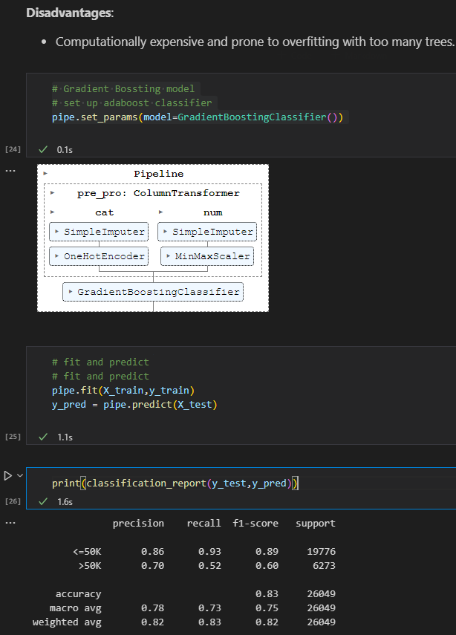

**Extreme Gradient Boosting**

# xg boost

from xgboost import XGBClassifier

# set up model

pipe.set_params(model=XGBClassifier())

# pipe.set_params(model=XGBClassifier(use_label_encoder=True))

# fit and predict

pipe.fit(X_train,y_train)

y_pred = pipe.predict(X_test)

print(classification_report(y_test,y_pred))

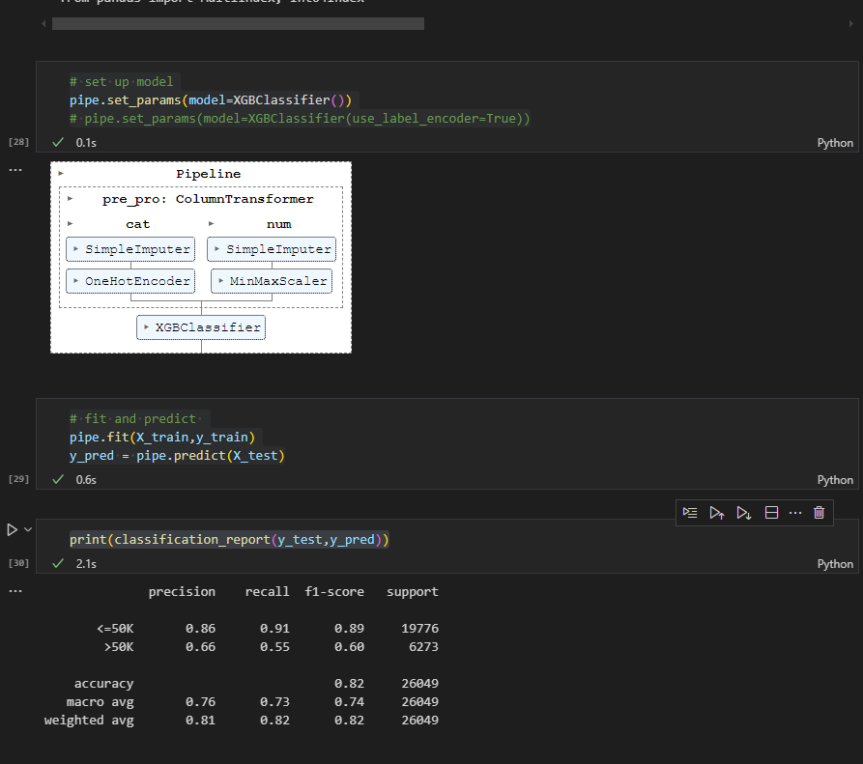

**TUNING USING GRID SEARCH CV**

param_grid = {

    'model__booster': ['gbtree', 'dart'],  # Type of boosting model ('gbtree' or 'dart')

    'model__learning_rate': [0.01, 0.1, 0.2],  # Step size in each boosting round

    'model__n_estimators': [50, 100, 200],  # Number of trees (boosting rounds)

    'model__max_depth': [3, 6, 10],  # Maximum depth of each tree

    'model__min_child_weight': [1, 3, 5],  # Minimum sum of instance weight in a child node

    'model__subsample': [0.7, 0.8, 1.0],  # Fraction of data to sample for each tree

    'model__colsample_bytree': [0.7, 0.8, 1.0],  # Fraction of features to sample for each tree

    'model__gamma': [0, 0.1, 0.2]  # Minimum loss reduction required to make a split

}

pipe.set_params(model = XGBClassifier() )

# perform grid search for the above model

grid = GridSearchCV(estimator=pipe,param_grid=param_grid)

grid

grid.fit(X_train,y_train)

y_pred = pipe.predict(X_test)

grid.best_estimator_

print(classification_report(y_test,y_pred))

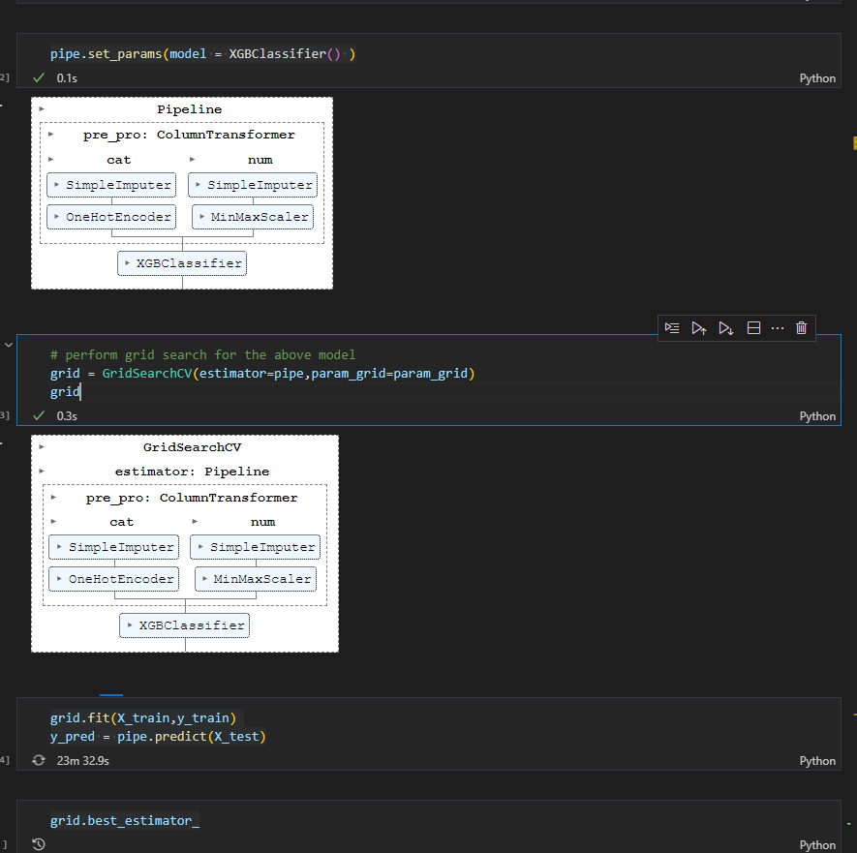

1. **Access Jokes Dataset on surprise library**

Workaround is to download and unzip http://eigentaste.berkeley.edu/dataset/archive/jester_dataset_2.zip and save the .dat files to ~/.surprise_data/jester/

i.e in ur working directory create folder surprise_data then inside surprise_data create folder jester and paste the unzipped files(.dat files) to jester folder and rerun the code

1. .fit not working in kmeans clustering( **AttributeError: 'NoneType' object has no attribute 'split'**)

for below code

k_means = KMeans(n_clusters=6)

k_means.fit(X)

predicted_clusters = k_means.predict(X)

Had to install threadpoolctl by running below code and then restart the kernel

!pip install threadpoolctl==3.1.0

1. **PCA**

# Import PCA

from sklearn.decomposition import PCA

# Instantiate PCA

pca = PCA(n_components=2)

# Fit PCA

principalComponents = pca.fit_transform(X)

# Create a new dataset from principal components

df2 = pd.DataFrame(data = principalComponents,columns=['PC1','PC2'])

target = df['Target']

result_df  = pd.concat([df2,target],axis=1)

# pd.Series(iris['target'], name='target')

result_df.head(5)

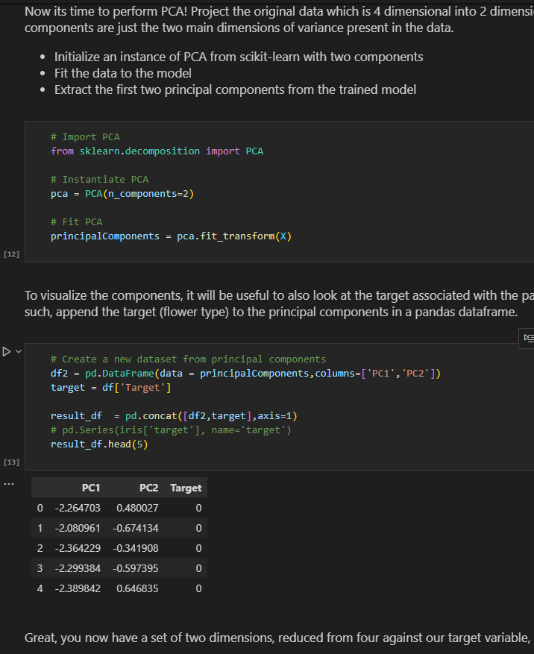

**Visualizing Principal Components** -Using the target data we can visualize the principal components according to the class distribution

# Principal Components scatter plot

# Your code here

fig,ax = plt.subplots()

plt.scatter(result_df['PC1'],result_df['PC2'],c=result_df['Target'])

targets = [0,1,2]

ax.set(xlabel='First Principal Component',ylabel='Second Pricipal Component',title='Principal Component Analysis (2PCs) for Iris Target' )

ax.legend(targets)

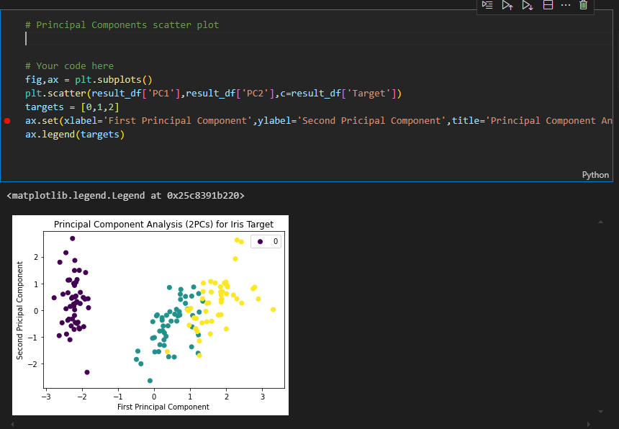

**Another Method**

#Teachers code

targets = [0,1,2]

colors = ['r','g','b']

fig, ax = plt.subplots()

for target, color in zip(targets, colors):

    indicesToKeep = iris['target'] == target

    ax.scatter(result_df.loc[indicesToKeep,'PC1'],

               result_df.loc[indicesToKeep,'PC2'],

               c=color,

               s=50

               )

ax.legend(targets)

ax.set_xlabel('First Principal Component ', fontsize = 15)

ax.set_ylabel('Second Principal Component ', fontsize = 15)

ax.set_title('Principal Component Analysis (2PCs) for Iris Dataset', fontsize = 20);

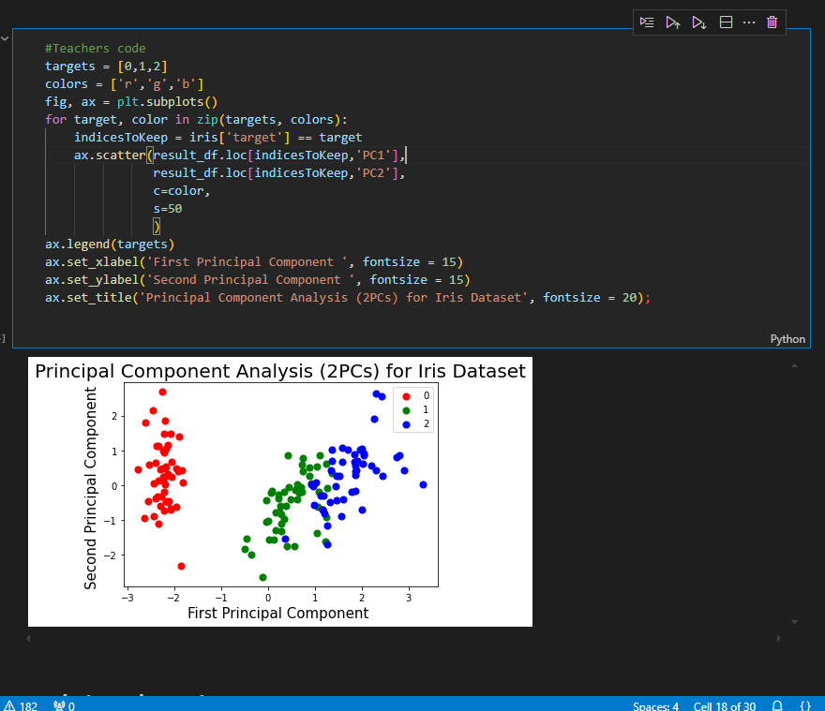

**Variance in PCA**

# Calculate the variance explained by principal components

import numpy as np

print('Variance of each component:', pca.explained_variance_ratio_)

print('\n Total Variance Explained:', round(sum(pca.explained_variance_ratio_),2))

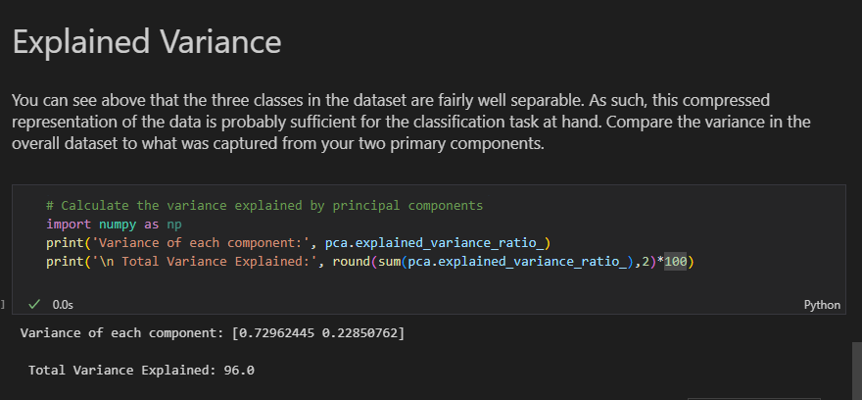

**Run Classifier on PCA Data**

X = result_df[['PC1', 'PC2']]

y = result_df['Target']

start = time.time()

X_train, X_test, Y_train, Y_test = train_test_split(X, y, test_size=0.2, random_state=9)

model = KNeighborsClassifier()

model.fit(X_train.values, Y_train.values)

Yhat = model.predict(X_test.values)

acc = accuracy_score(Yhat, Y_test.values)

end = time.time()

print('Accuracy:', acc)

print ('Time Taken:', end - start)

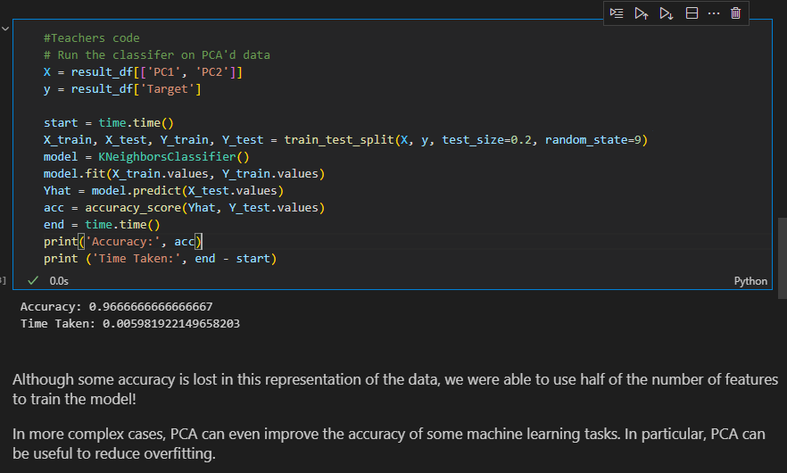

**Integrating PCA with Pipelines**

**a)BaseModel**

y = data['target']

X = data.loc[:,'feat_1':'feat_93']

# Your code here

# Load and split the data

X_train,X_test,y_train,y_test = train_test_split(X,y,test_size=0.4,random_state=42)

# Your code here

# Construct some pipelines

pipe = Pipeline([

    ('pca',PCA(n_components=27,random_state=123)),  # PCA step

     ('model',LogisticRegression(random_state=123)) # Logistic Regression step

])

# Your code here

pipe.fit(X_train,y_train)

y_predicted = pipe.predict(X_test)

pipe.score(X_test,y_test)

# Your code here

np.sum(y_predicted == y_test)/len(y_test)

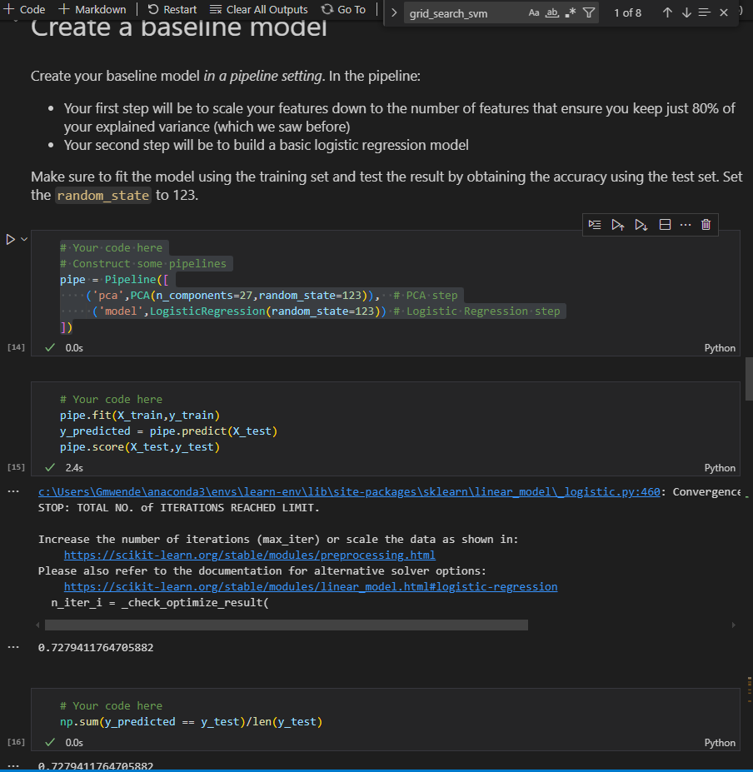

**b) Create a pipeline consisting of a linear SVM, a simple decision tree, and a simple random forest classifier**

# Your code here

# ⏰ This cell may take several minutes to run

pipe_decision= Pipeline([

    ('pca',PCA(n_components=27,random_state=123)),  # PCA step

     ('model_decision',DecisionTreeClassifier(random_state=123)) # Decision Tree step

])

pipe_rf = Pipeline([

    ('pca',PCA(n_components=27,random_state=123)),  # PCA step

     ('model_random',RandomForestClassifier(random_state=123)) # Random Forest step

])

pipe_svm = Pipeline([

    ('pca',PCA(n_components=27,random_state=123)),  # PCA step

     ('model_svm',svm.SVC(random_state=123)) # SVM step

])

# Loop to fit each of the three pipelines

pipelines = [pipe_decision,pipe_rf,pipe_svm]

pipeline_name=['Decision Tree','Random Forest','Support Vector Machine']

for pipe in pipelines:

    print(pipe)

    pipe.fit(X_train,y_train)

    # scores = pipe.score(X_test,y_test)

    # print(scores)

# #compare accuracies

for i,val in enumerate(pipelines):

    scores = val.score(X_test,y_test)

    print(f'Pipeline test accuracy:  {pipeline_name[i]}: {scores:.3f}')

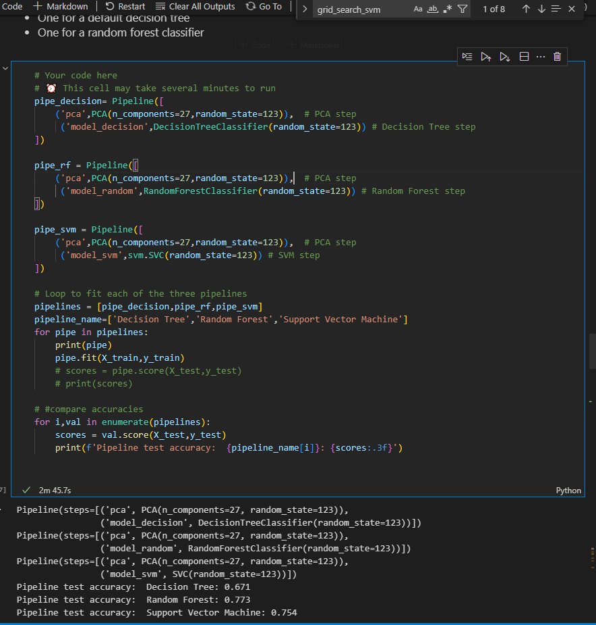

1. **Pipeline with Grid Search**
2. # Your code here
3. # imports
4. pipe_rf = Pipeline([
5. ('pca',PCA(n_components=27,random_state=123)),  # PCA step
6. ('model_random',RandomForestClassifier(random_state=123)) # Random Forest step
7. ])
8. param_grid = [
9. {'model_random__n_estimators': [120],
10. 'model_random__criterion': ['entropy', 'gini'],
11. 'model_random__max_depth': [4, 5, 6],
12. 'model_random__min_samples_leaf':[0.05 ,0.1, 0.2],
13. 'model_random__min_samples_split':[0.05 ,0.1, 0.2]
14. }
15. ]
16. grid_search_rf = GridSearchCV(estimator=pipe_rf,param_grid=param_grid,scoring='accuracy',
17. cv=3, verbose=2, return_train_score = True)
18. grid_search_rf.fit(X_train,y_train)
19. grid_search_rf.score(X_test,y_test)
20. # Your code here
21. # Best accuracy
22. print('Best accuracy: %.3f' % grid_search_rf.best_score_)
23. # Best params
24. print('\nBest params:\n', grid_search_rf.best_params_)
25. grid_search_rf.cv_results_

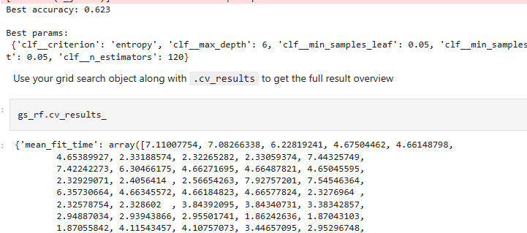

1. **Market Segmentation/Clustering**

channels = raw_df['Channel']

# df = raw_df.drop(columns=['Channel','Region'])

df = raw_df.drop(['Channel','Region'],axis=1)

df.head()

**Clustering Analysis Using Kmeans**

from sklearn.cluster import KMeans

k_means = KMeans(n_clusters=2)

k_means.fit(df)

cluster_preds = k_means.predict(df)

from sklearn.metrics import calinski_harabasz_score,adjusted_rand_score

calinski_harabasz_score(df,cluster_preds)

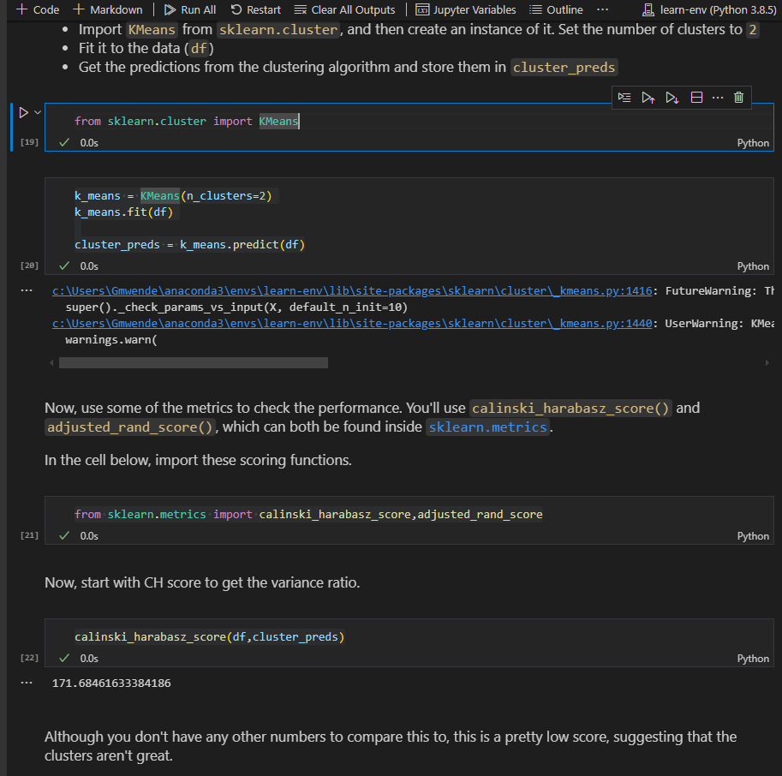

**adjusted_rand_score**

adjusted_rand_score(channels,cluster_preds)

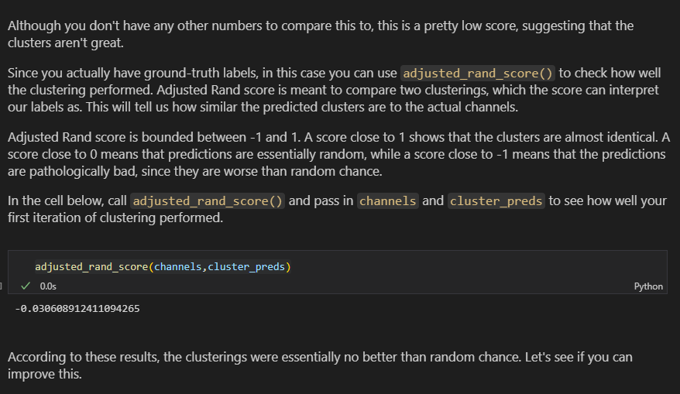

**Kmeans After Scaling**

from sklearn.preprocessing import StandardScaler

scaler = StandardScaler()

scaled_df = scaler.fit_transform(df)

scaled_k_means = KMeans(n_clusters=2)

scaled_k_means.fit(scaled_df)

scaled_preds = scaled_k_means.predict(scaled_df)

adjusted_rand_score(channels,scaled_preds)

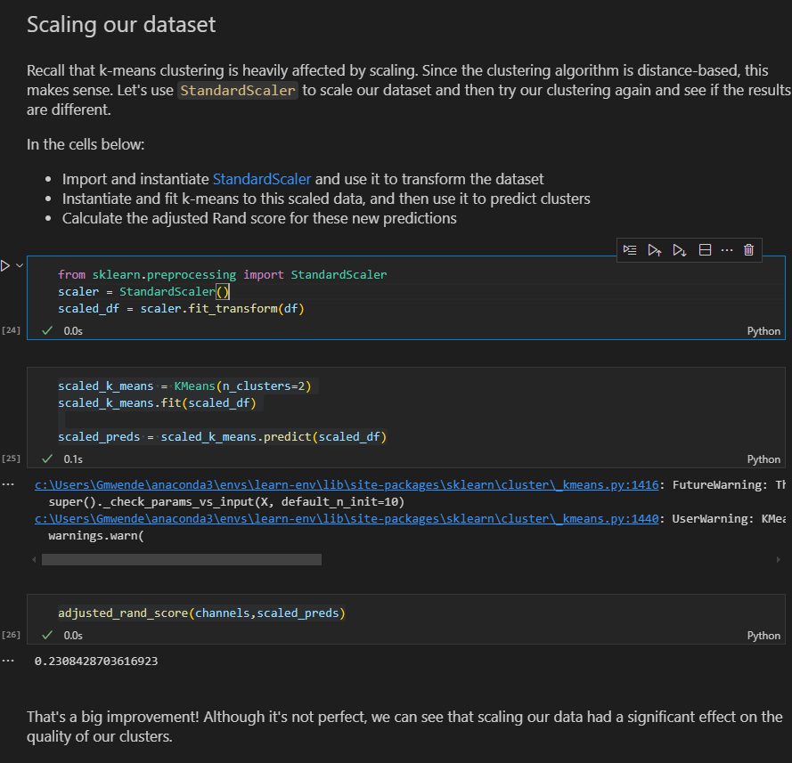

**Incorporating pca**

from sklearn.decomposition import PCA

pca=  PCA(n_components=4)

pca_df = pca.fit_transform(scaled_df)

np.cumsum(pca.explained_variance_ratio_)

pca_kmeans = KMeans(n_clusters=2)

pca_kmeans.fit(pca_df)

pca_predict = pca_kmeans.predict(pca_df)

adjusted_rand_score(channels,pca_predict)

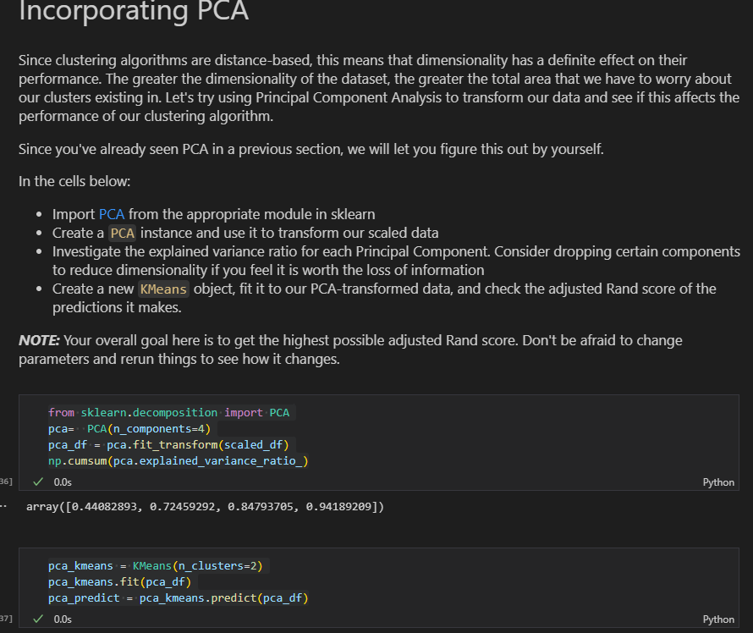

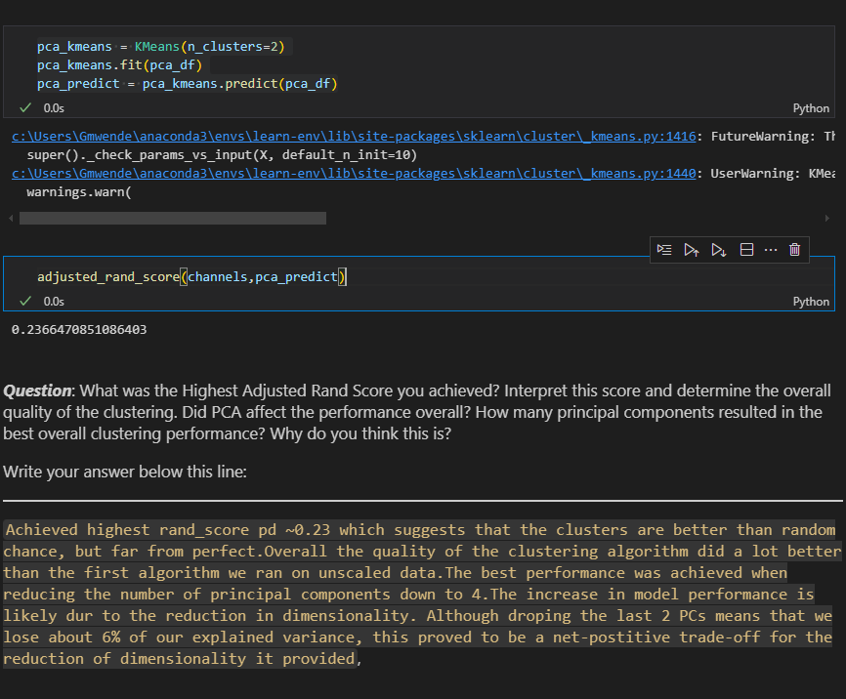

1. **Hierarchical Agglomerative Clustering**

from sklearn.cluster import AgglomerativeClustering

# unscaled dataset

agg_clust = AgglomerativeClustering(n_clusters=2)

agg_clust.fit(df)

agg_clust_predict = agg_clust.fit_predict(df)

adjusted_rand_score(channels,agg_clust_predict)

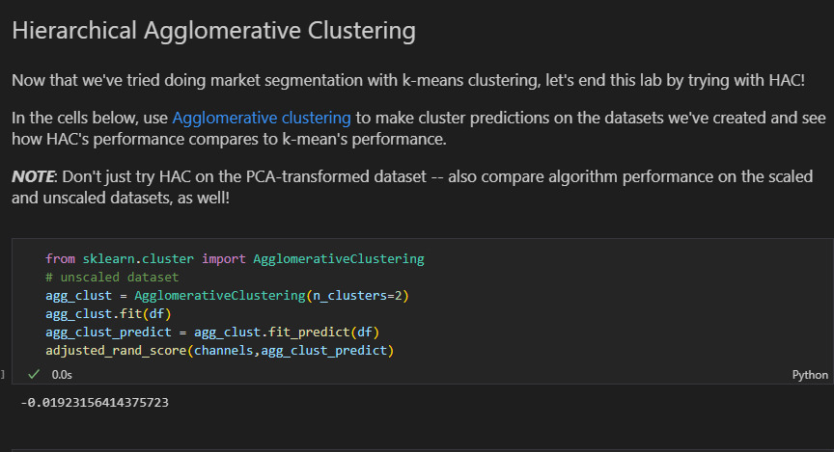

**#Scaled dataset and after pca**

#scaled dataset

agg_clust_sc = AgglomerativeClustering()

agg_clust_sc.fit(scaled_df)

agg_clust_sc_predict = agg_clust_sc.fit_predict(scaled_df)

adjusted_rand_score(channels,agg_clust_sc_predict)

#after pca

pca = PCA(n_components=4)

pc_df_agg = pca.fit_transform(scaled_df)

np.cumsum(pca.explained_variance_ratio_)

pca_agg = AgglomerativeClustering()

pca_agg.fit(pc_df_agg)

pca_agg_clust_predict = pca_agg.fit_predict(pc_df_agg)

adjusted_rand_score(channels,pca_agg_clust_predict)

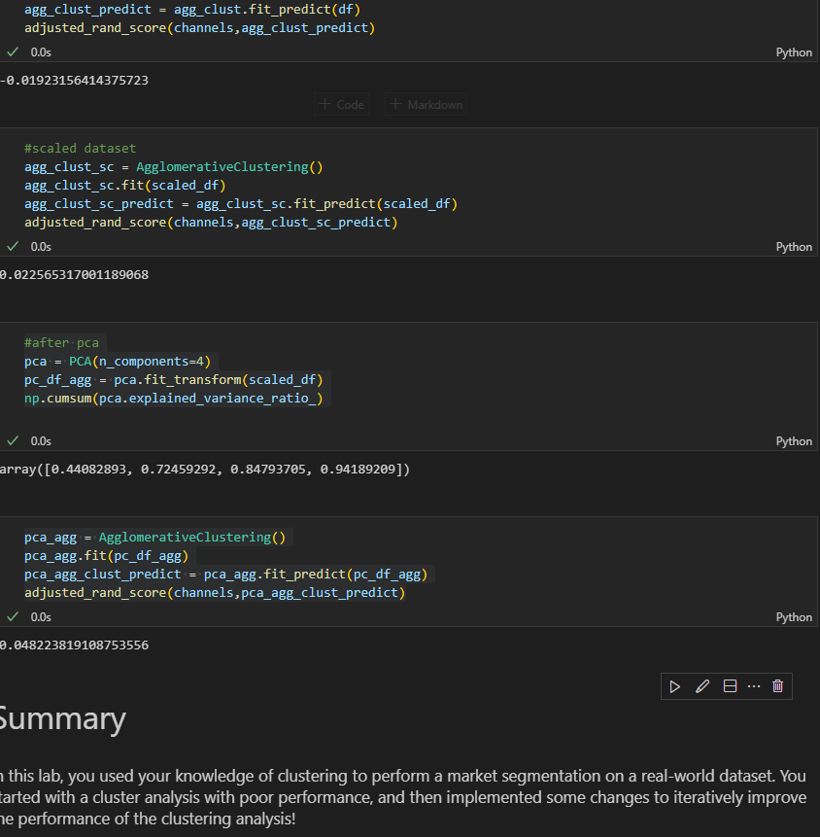

1. **Tensorflow error**

**ImportError**: cannot import name 'array_to_img' from 'tensorflow.keras.utils'

from tensorflow.keras.utils import array_to_img

from keras.utils import array_to_img

from tensorflow.keras.preprocessing.image import array_to_img

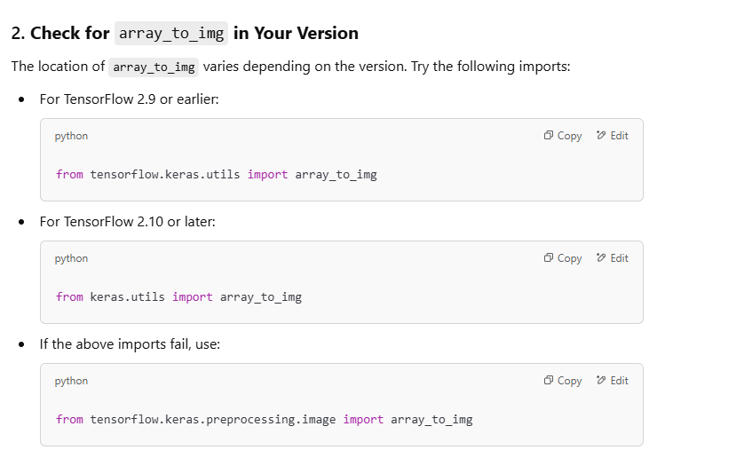

1. **Deep Learning**

**Create model and add layers**

model_3 = Sequential()

model_3.add(Dense(10,activation='tanh',input_shape=(30,))) #30 columns

model_3.add(Dense(5,activation='tanh'))

model_3.add(Dense(1,activation='sigmoid')) #binary and softmax for multiclass

1. **Model Images**

model =  Sequential()

model.add(Input(shape=(28,28,1)))

#hidden

model.add(Conv2D(32,(3,3),activation='relu'))

model.add(Conv2D(64,(3,3),activation='relu'))

model.add(Flatten())

model.add(Dense(32,activation='relu'))

model.add(Dense(16,activation='relu')) #improves model perfomance by removing negative function

model.add(Dense(10,activation='softmax'))

1. **Compiling the model**

model_3.compile(

    optimizer='sgd',

    loss = 'binary_crossentropy',

    metrics=['acc'] #metrics = ['precision','accuracy']

)

1. **Train the model**

results_3 = model_3.fit(

    df,

    labels,

    epochs = 25,

    batch_size=1,

    validation_split = 0.2

)

**Or**

model.fit(training_data,

         epochs=20,

         batch_size=32,

         validation_data=validation)

**Or**

# Train the model

normalized_input_model.fit(X_train,

                          y_train,

                          batch_size = 32,

                          epochs =150,

                          validation_data = (X_val,y_val)

                          )

1. **Evaluate Model**

normalized_model.evaluate(X_train,y_train_scaled)

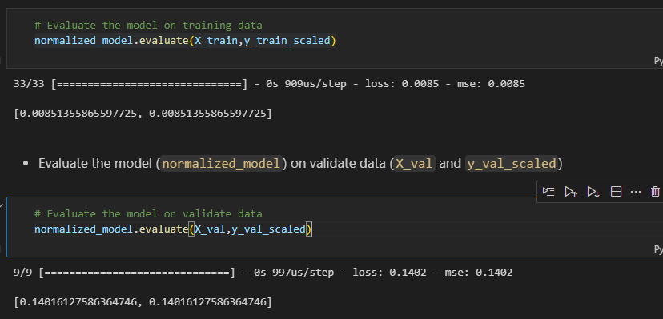

1. **If we had normalized data we have to take it back to original scale**

# Generate predictions on validate data

y_val_pred_scaled = normalized_model.predict(X_val)

# Transform the predictions back to original scale

y_val_pred = ss_y.inverse_transform(y_val_pred_scaled)

# RMSE of validate data

np.sqrt(mean_squared_error(y_val,y_val_pred))

1. **Train test split**
2. # Split data into training and test sets
3. X_train, X_test, y_train, y_test = train_test_split(X,y,test_size=1500,random_state=42)
4. **Data for validation**

it is good practice to set aside a validation set, which is then used during hyperparameter tuning. Afterwards, when you have decided upon a final model, the test set can then be used to determine an unbiased perforance of the model.

1. **Get history, loss and accuracy**

history_dict = history.history

loss_values = history_dict['loss']

epochs = range(1,len(loss_values)+1)

plt.plot(epochs,loss_values,'g',label='Training loss')

plt.xlabel('Epochs')

plt.ylabel('Loss')

plt.legend()

1. plt.show();

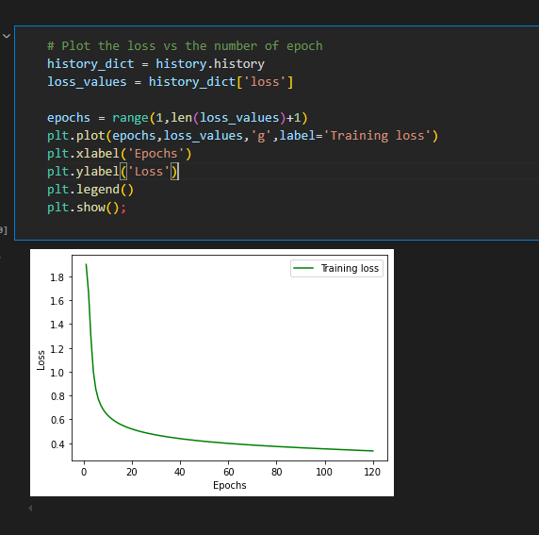

1. **Accuracy**

# Plot the training accuracy vs the number of epochs

acc_values = history_dict['acc']

plt.plot(epochs,acc_values,'r',label='Training acc')

plt.title('Training accuracy')

plt.xlabel('Epochs')

plt.ylabel('Accuracy')

plt.legend()

plt.show();

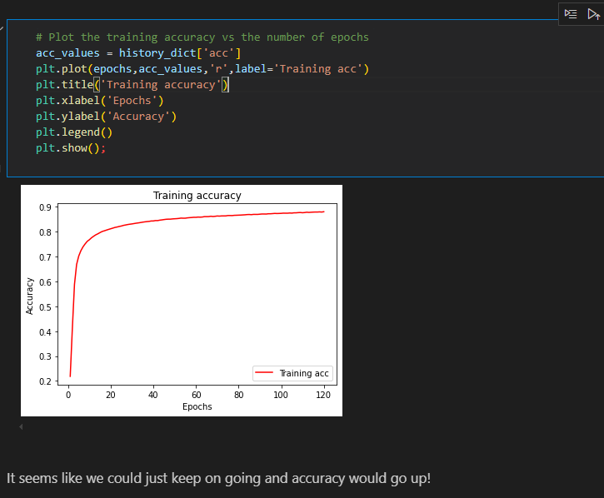

1. # Split the data into training and validation sets
2. X_train_final, X_val, y_train_final, y_val = train_test_split(X_train, y_train, test_size=1000, random_state=42)